MATLAB post processing
MATLAB calls STAR-CCM+ in batch to get and plot reports (e.g. aero forces and coefficients) vs a sweep variable (e.g. angle of attack) from a list of sim files.

Detailed description
Calls STAR-CCM+ in batch with a macro to get and plot the desired reports versus an independent variable. Useful to list and plot data from a design sweep like an airfoil investigated at several angles of attack, where each sim file is an angle of attack. Works with Microsoft Windows. The STAR-CCM+ executable starccm+.exe must be in the Windows path. The MATLAB script is configured to work with Power-on-Demand (PoD) license. The appropriate PoD string must be written by the user in the pod.txt file.
It is assumed that the sim file name has the numeric independent variable in the last characters. MATLAB will try to get the prefix of this file name, i.e. the root of the name without the independent variable value. For instance:
mysimfile_alpha0.0.sim --> prefix = mysimfile_alpha
or
mysimfile_alpha0.sim --> prefix = mysimfile_alpha
This script will work well with the last characters as floating point digits, even with zero decimal positions. The script will ask the user to check if the prefix has been correctly captured, otherwise it asks the user to write the prefix.
Launch the post.m MATLAB script. It will prompt you to navigate through the folders to select a sim file.
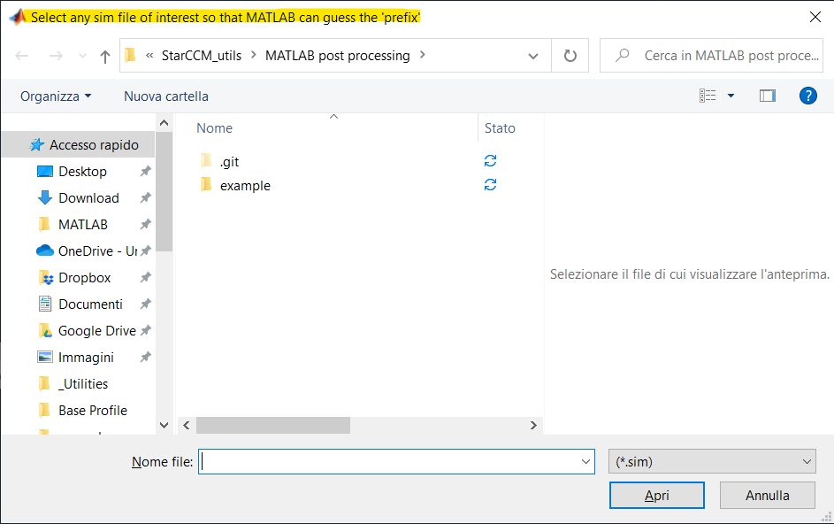
Select only a sim file to make MATLAB guess the root string (prefix)
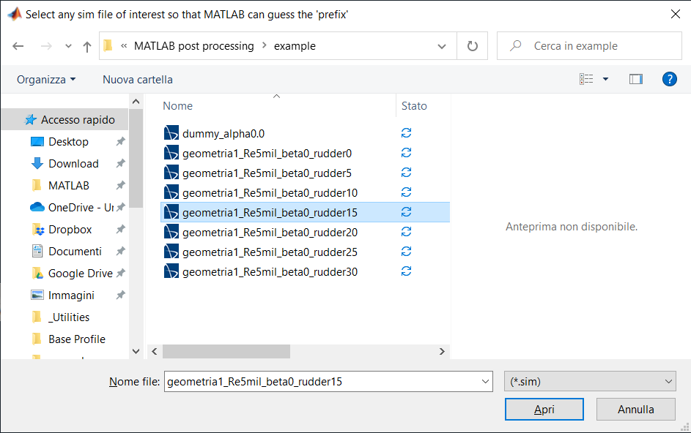
MATLAB asks the user if the prefix is correct. If not, it will ask to write the prefix.
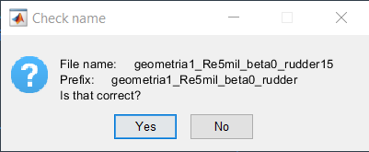
Write the independent variable name (not mandatory), it will be used in the final resume table and as x-axis label on the plots.
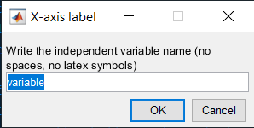

Then the script will ask the user to choose the sim files from which extract all the reports with the JAVA macro Report_to_csv.java. The sim files are all those with the same prefix previously defined, in the folder initially selected, so that it should be easy to get the files of interest even if the folder is populated with many and different file types. Sparse selection (e.g. non-contiguous angles of attack) is also permitted.
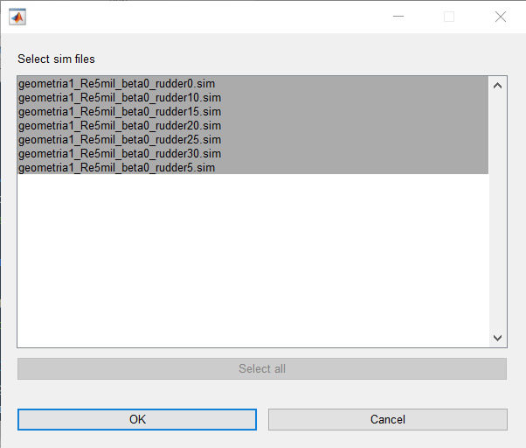
Finally, the script asks the user which report to plot versus the independent variable.
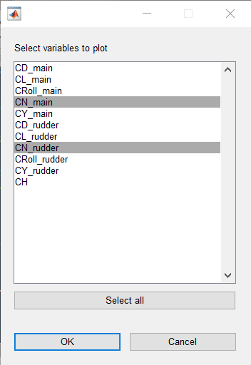
The script generates a plot for each report chosen and writes a table in the command window. Such data is stored in the var variable. It is important to have each variable written as a char array without spaces, symbols, or special character, otherwise the MATLAB table throws an error.
